# Assignment #4

Turn in your work as **a single Word or PDF file**.

|  |  |  |  |  |  |  |  |  |
| --- | --- | --- | --- | --- | --- | --- | --- | --- |
| **Problem 1** | | | | | | **Problem 2** | | **Total** |
| **1.1** | **1.2** | **1.3** | **1.4** | **1.5** | **1.6** | **2.1** | **2.2** |
| 5 pts | 20 pts | 15 pts | 10 pts | 5 pts | 5 pts | 20 pts | 20 pts | 100 pts |

1. **Specification-Based Testing (Refer to the lecture notes)**

The specification of the TriangleSides program is as follows:

Precondition

a>0 and b>0 and c>0

Postcondition

IF (a+b>c and a+c>b and b+c>a)

IF (a=b AND b=c)

THEN return EQUILATERAL

IF ((a=b and b≠c) or (a=c and b≠c) or (b=c and b≠a))

THEN return ISOSCELES

IF (a≠b and b≠c and a≠c)

THEN return SCALENE

ELSE return NOTRIANGLE

* 1. Define the test requirements from the precondition. (**4 points**)

(a,b,c > 0)

* 1. Define the test requirements from the postcondition. (**20 points**)

|  |  |  |
| --- | --- | --- |
| No. | Input condition | Expected Result |
| 1 | (a + b < c, a + c > b, b + c > a) | NOTRIANGLE |
| 2 | (a + b > c, a + c < b, b + c > a) | NOTRIANGLE |
| 3 | (a + b > c, a + c > b, b + c < a) | NOTRIANGLE |
| 4 | (a == b and b == c) AND (a + b > c, a + c > b, b + c > a) | EQUILATERAL |
| 5 | (a = b and b != c), (a != c and b = c), (b != c and b = a) AND (a + b > c, a + c > b, b + c > a) | ISOSCELES |
| 6 | (a != b and b = c), (a = c and b != c), (b != c and b = a) AND (a + b > c, a + c > b, b + c > a) | ISOSCELES |
| 7 | (a != b and b = c), (a != c and b = c), (b = c and b != a) AND (a + b > c, a + c > b, b + c > a) | ISOSCELES |
| 8 | (a != b, b != c, a != c) AND (a + b > c, a + c > b, b + c > a) | SCALENE |

Highlighted sections are where n requirements are due to corresponding ‘and’/’or’ in ‘if’/’else’

* 1. Use the following table to present the combined test requirements from Problems 1.1 and 1.2. Add as many rows as needed. (**16 points**)

|  |  |  |
| --- | --- | --- |
| **#** | **Input condition** | **Expected result** |
| 1 | (a,b,c > 0) AND (a + b < c, a + c > b, b + c > a) | NOTRIANGLE |
| 2 | (a,b,c > 0) AND (a + b > c, a + c < b, b + c > a) | NOTRIANGLE |
| 3 | (a,b,c > 0) AND (a + b > c, a + c > b, b + c < a) | NOTRIANGLE |
| 4 | (a,b,c > 0) AND (a == b and b == c) AND (a + b > c, a + c > b, b + c > a) | EQUILATERAL |
| 5 | (a,b,c > 0) AND (a = b and b != c), (a != c and b = c), (b != c and b = a) AND (a + b > c, a + c > b, b + c > a) | ISOSCELES |
| 6 | (a,b,c > 0) AND (a != b and b = c), (a = c and b != c), (b != c and b = a) AND (a + b > c, a + c > b, b + c > a) | ISOSCELES |
| 7 | (a,b,c > 0) AND (a != b and b = c), (a != c and b = c), (b = c and b != a) AND (a + b > c, a + c > b, b + c > a) | ISOSCELES |
| 8 | (a,b,c > 0) AND (a != b, b != c, a != c) AND (a + b > c, a + c > b, b + c > a) | SCALENE |

* 1. Create a test case for each of the combined test requirements in Problem 1.3. (**10 points**)

|  |  |  |  |  |
| --- | --- | --- | --- | --- |
| **#** | **Test input** | | | **Expected result** |
| **a** | **b** | **c** |
| 1 | 1 | 2 | 5 | NOTRIANGLE |
| 2 | 2 | 1 | 5 | NOTRIANGLE |
| 3 | 5 | 2 | 1 | NOTRIANGLE |
| 4 | 3 | 3 | 3 | EQUILATERAL |
| 5 | 2 | 2 | 3 | ISOSCELES |
| 6 | 2 | 3 | 2 | ISOSCELES |
| 7 | 3 | 2 | 2 | ISOSCELES |
| 8 | 3 | 4 | 5 | SCALENE |

* 1. Write a Junit class TriangleSpecficationTest.java in the “correct” package to implement all the test cases in Problem 1.4. Run and debug TriangleSpecficationTest.java in the “correct” package until there is no failure (if there is a failure, then something is wrong with your tests and you must fix it). **Note that the tests in TriangleSpecficationTest.java must include only those from Problems 1.4.**

Provide the source code of your TriangleSpecficationTest.java and a screenshot of your test execution result. (**5 points**)

package correct;

import static org.junit.Assert.*;

import org.junit.After;

import org.junit.Before;

import org.junit.Test;

public class TriangleSpecificationTest {

@Before

public void setUp() throws Exception {

}

@After

public void tearDown() throws Exception {

}

@Test

public void test_1() {

assertEquals("", new TriangleSides(1,2,5).reportTriangleType(), TriangleSides.TriangleType.NOTRIANGLE);

}

@Test

public void test_2() {

assertEquals("", new TriangleSides(2,1,5).reportTriangleType(), TriangleSides.TriangleType.NOTRIANGLE);

}

@Test

public void test_3() {

assertEquals("", new TriangleSides(5,2,1).reportTriangleType(), TriangleSides.TriangleType.NOTRIANGLE);

}

@Test

public void test_4() {

assertEquals("", new TriangleSides(3,3,3).reportTriangleType(), TriangleSides.TriangleType.EQUILATERAL);

}

@Test

public void test_5() {

assertEquals("", new TriangleSides(2,2,3).reportTriangleType(), TriangleSides.TriangleType.ISOSCELES);

}

@Test

public void test_6() {

assertEquals("", new TriangleSides(2,3,2).reportTriangleType(), TriangleSides.TriangleType.ISOSCELES);

}

@Test

public void test_7() {

assertEquals("", new TriangleSides(3,2,2).reportTriangleType(), TriangleSides.TriangleType.ISOSCELES);

}

@Test

public void test_8() {

assertEquals("", new TriangleSides(3,4,5).reportTriangleType(), TriangleSides.TriangleType.SCALENE);

}

}

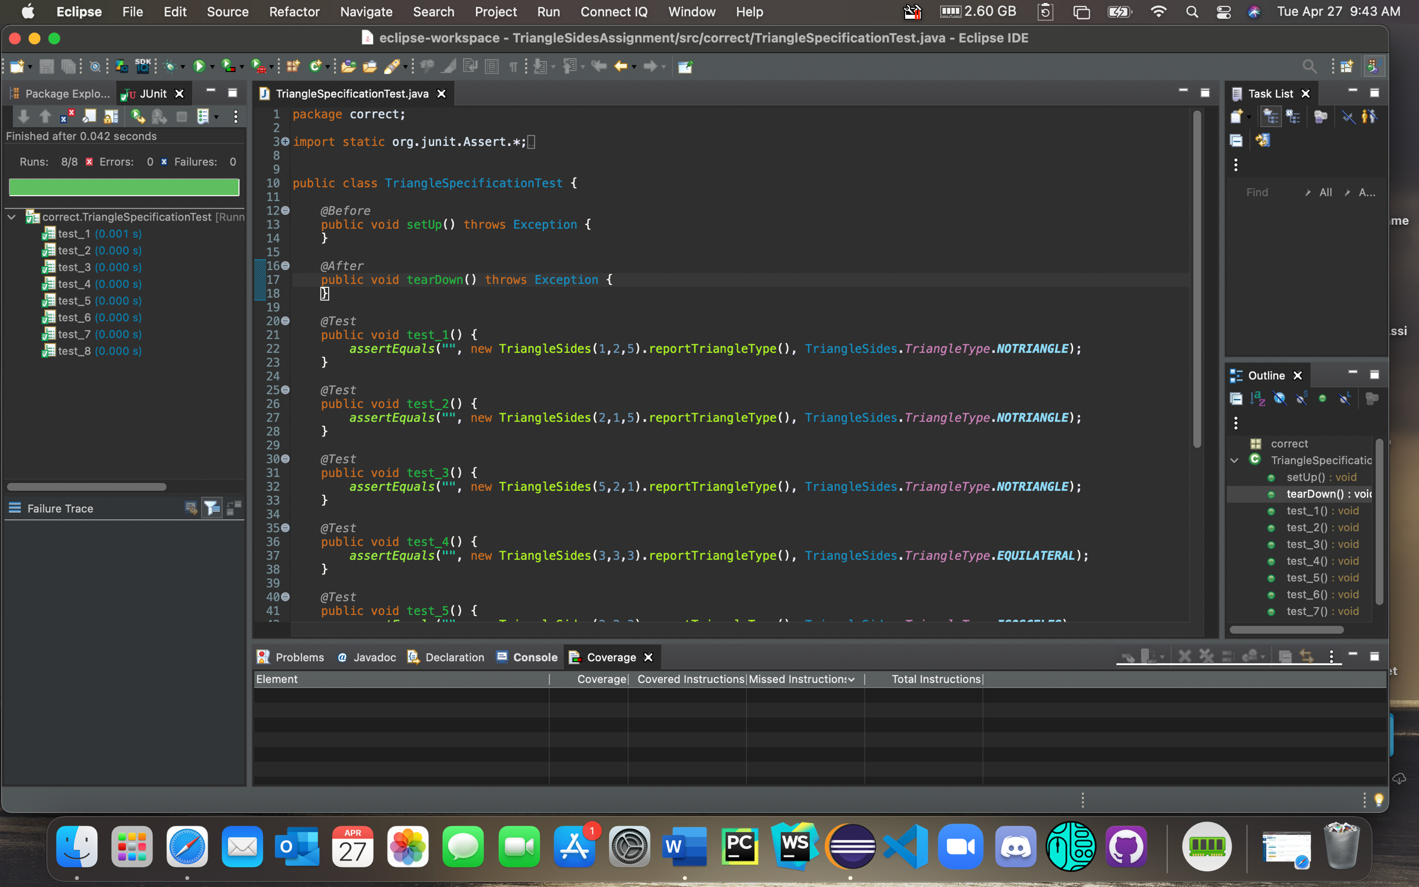

* 1. Copy your TriangleSpecficationTest.java in Problem 1.5 to each mutantX (X=1, 2, …, 9) package. Make sure the package statement in TriangleSpecficationTest.java is correct so that you can test TriangleSides.java in the same package. Report your test results in the table below and provide a screenshot of the test execution result for each mutantX package. (**5 points**)

**Note: To get full credits for Problems 1.1-1.5, your tests must be able to kill at least 5 mutants.**

|  |  |  |
| --- | --- | --- |
| *mutantX* | *Test failure: Yes or No?* | *If Yes, list the tests that failed; If No, explain why there is no failure according to the fault detection condition* |
| 1 | Yes | test_3 |
| 2 | Yes | test_7 |
| 3 | Yes | test_7 |
| 4 | Yes | test_8 |
| 5 | Yes | test_1, test_2, test_3 |
| 6 | Yes | test_8 |
| 7 | No | No failure because mutant requires b=a+c to fail, however, b<a+c and b>a+c was used in my tests to ensure desired outcomes |
| 8 | No | No failure because precondition requirements desire a,b,c > 0 and in order for failure a or b or c < 0 (would still be notriangle since final else statement would still return notriangle) |
| 9 | No | No failure because this mutant removes the precondition, in tests the preconditions still exist, and the code would still return notriangle as it is in final else statement |

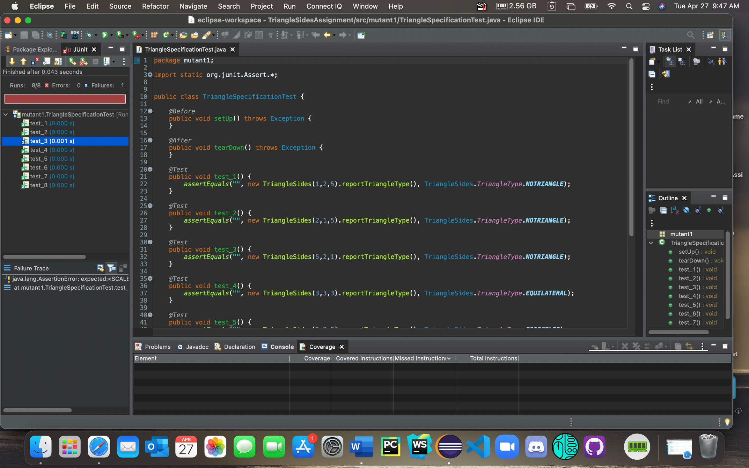

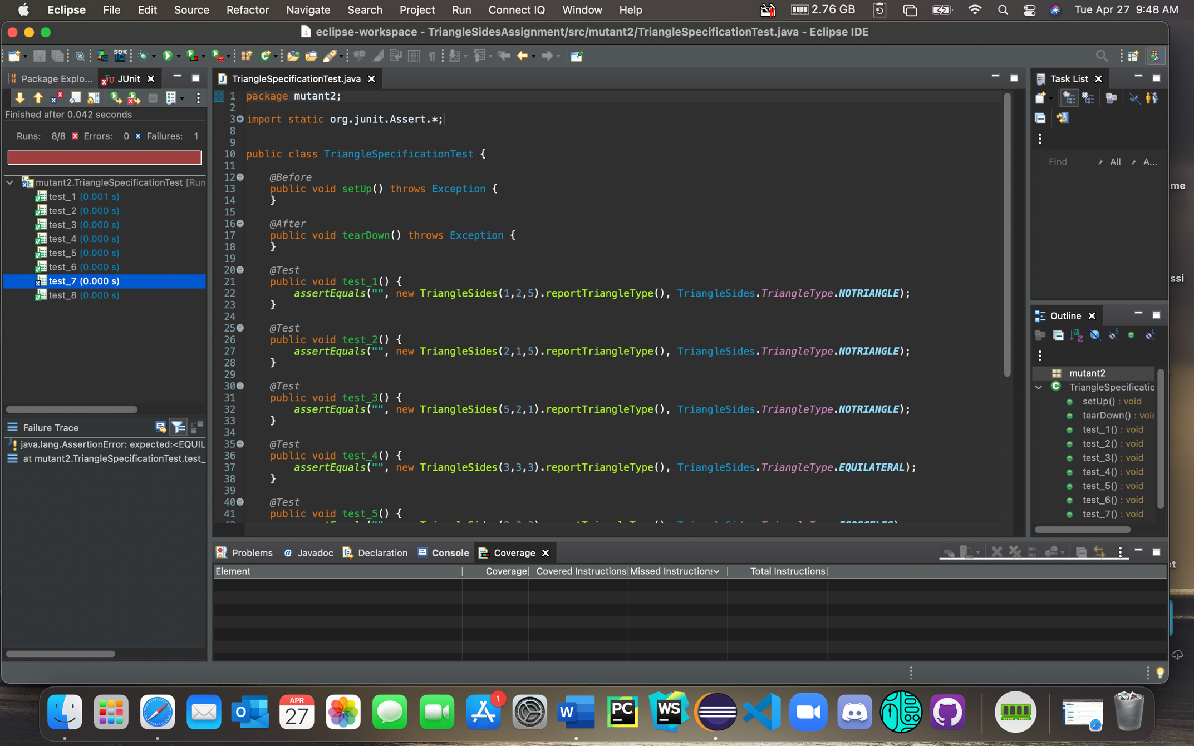

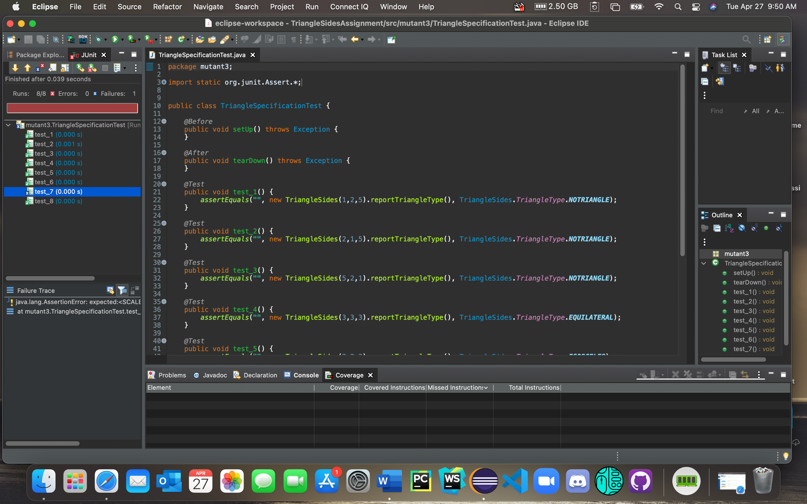

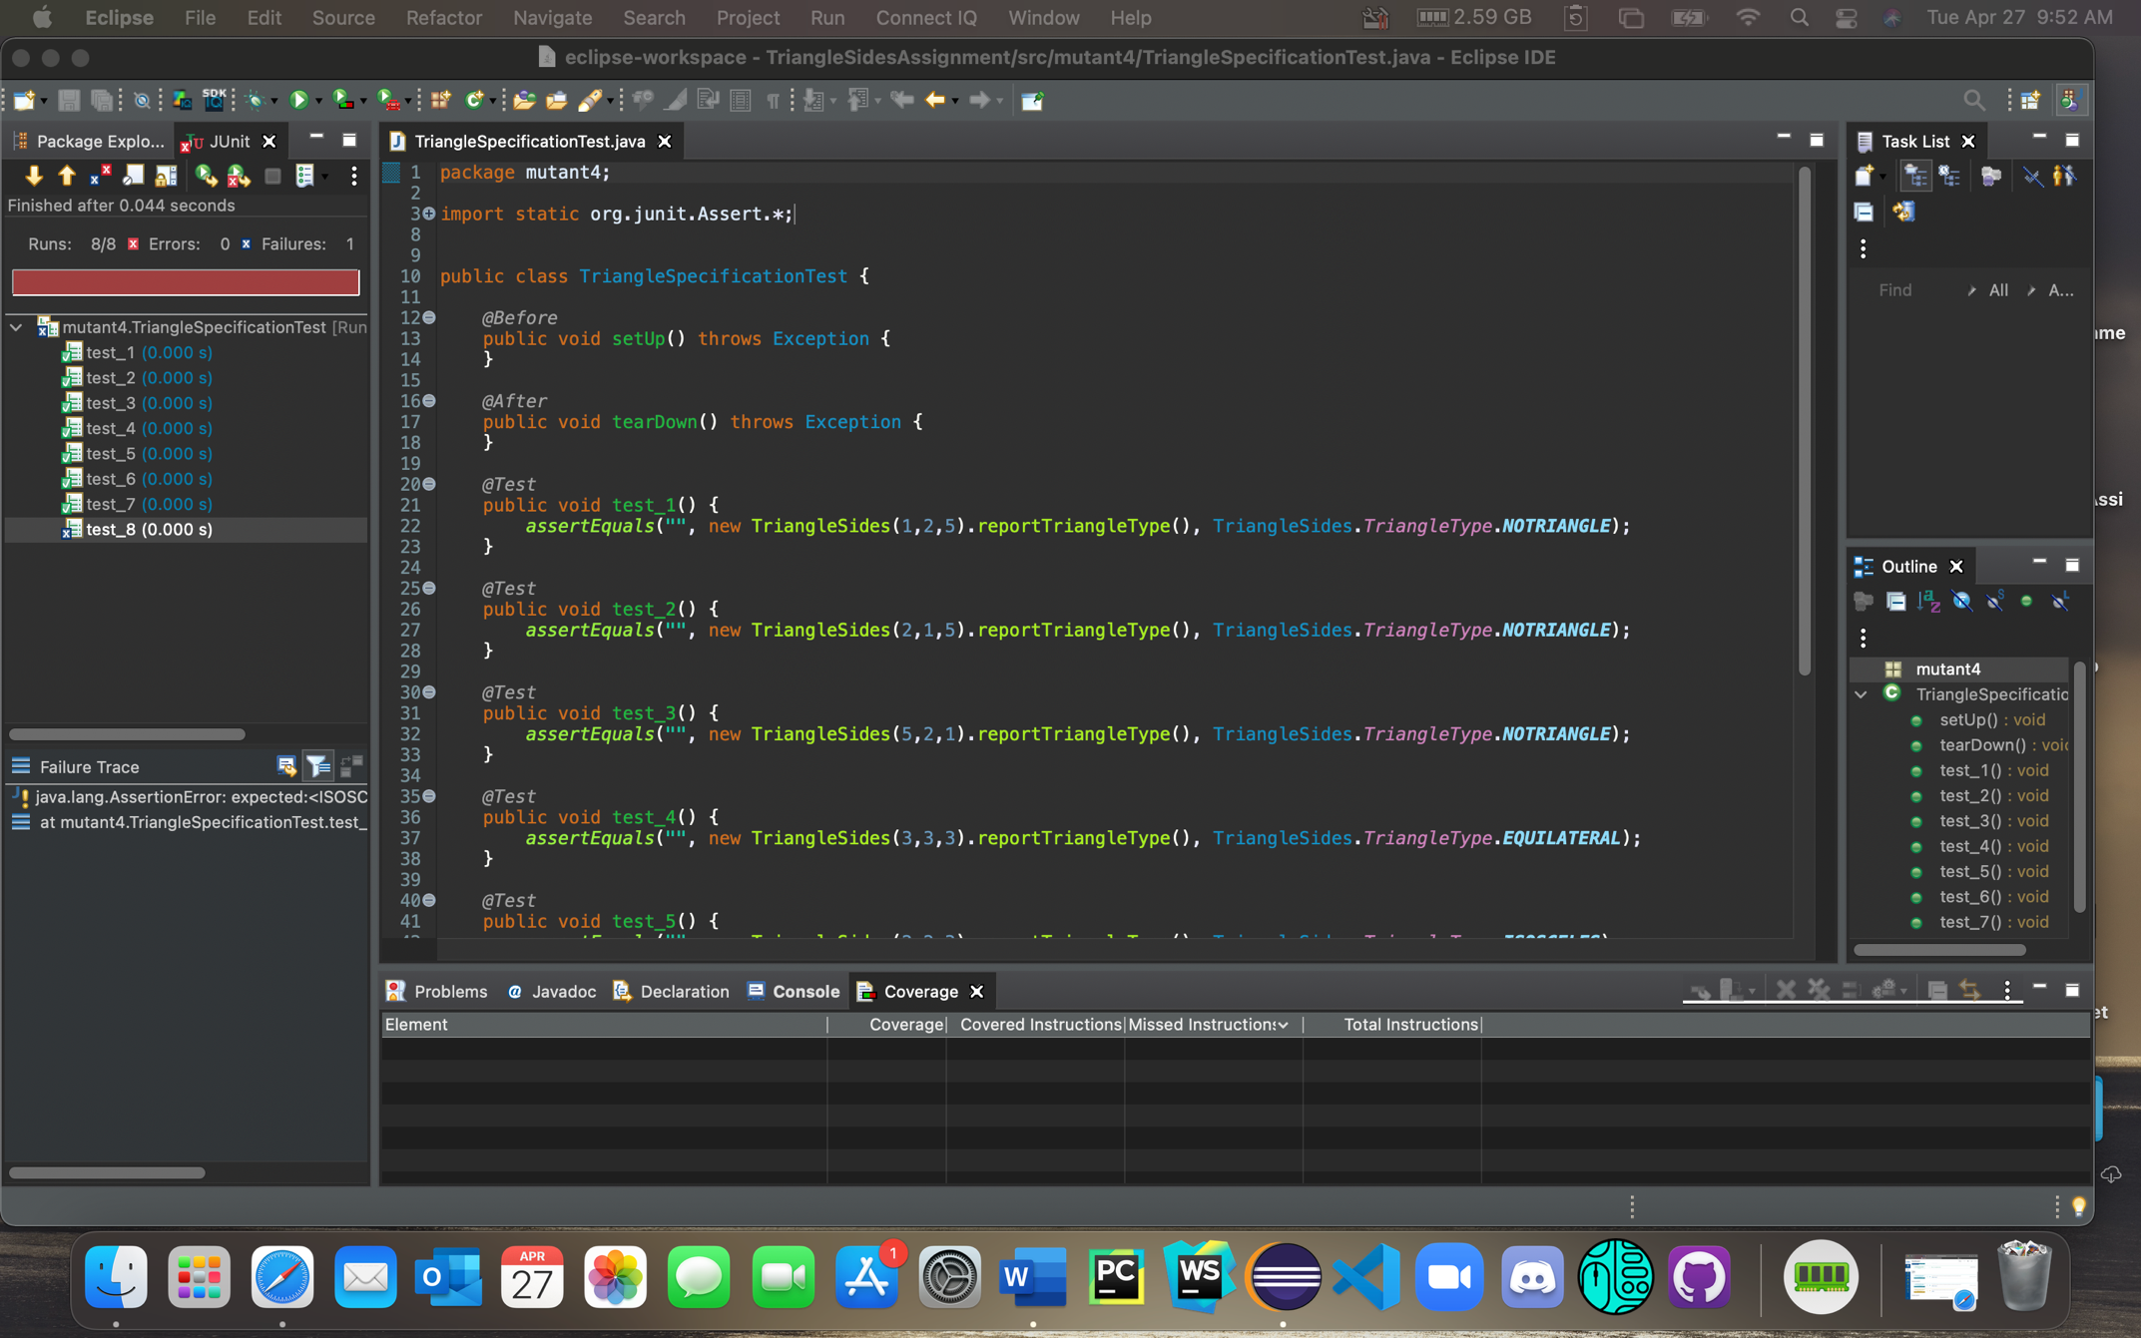

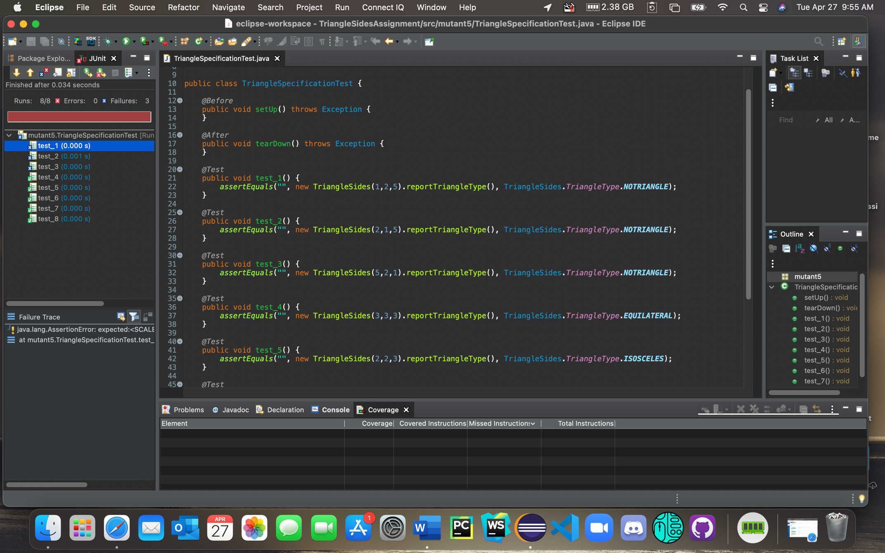

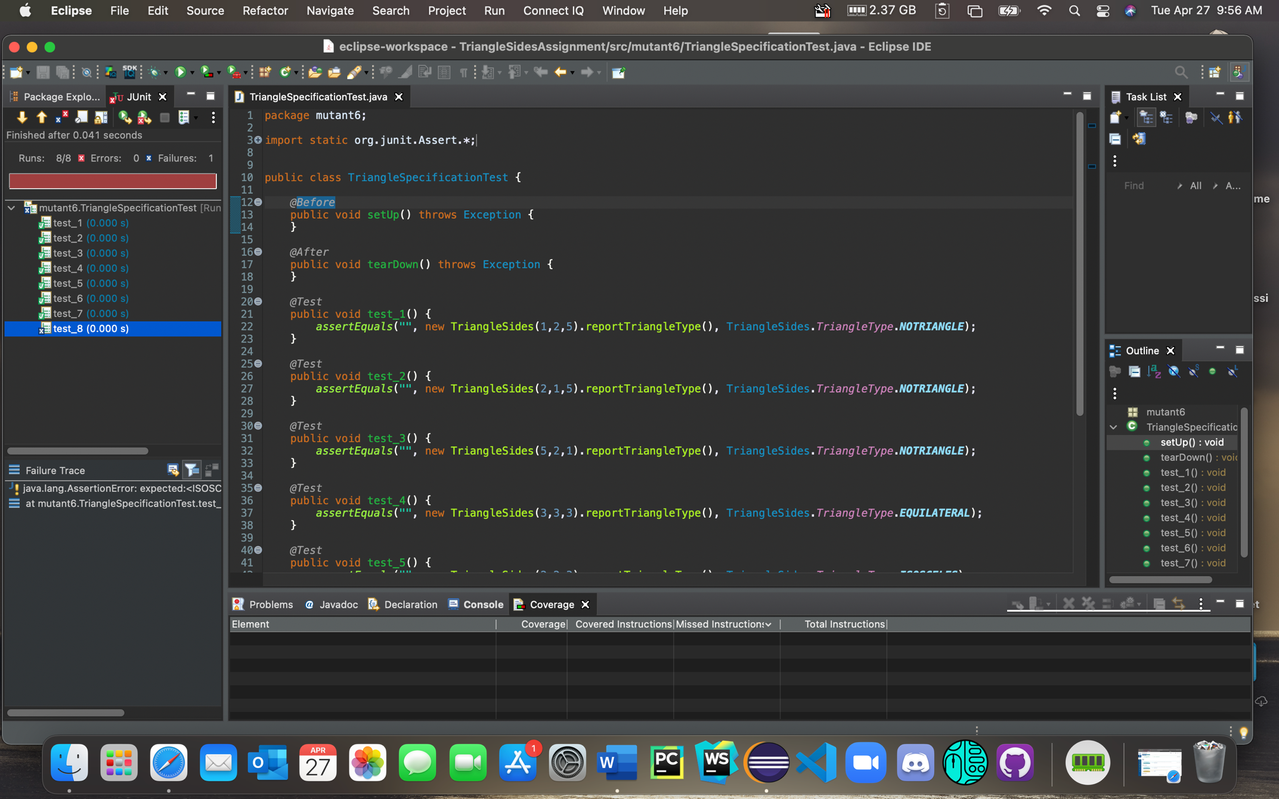

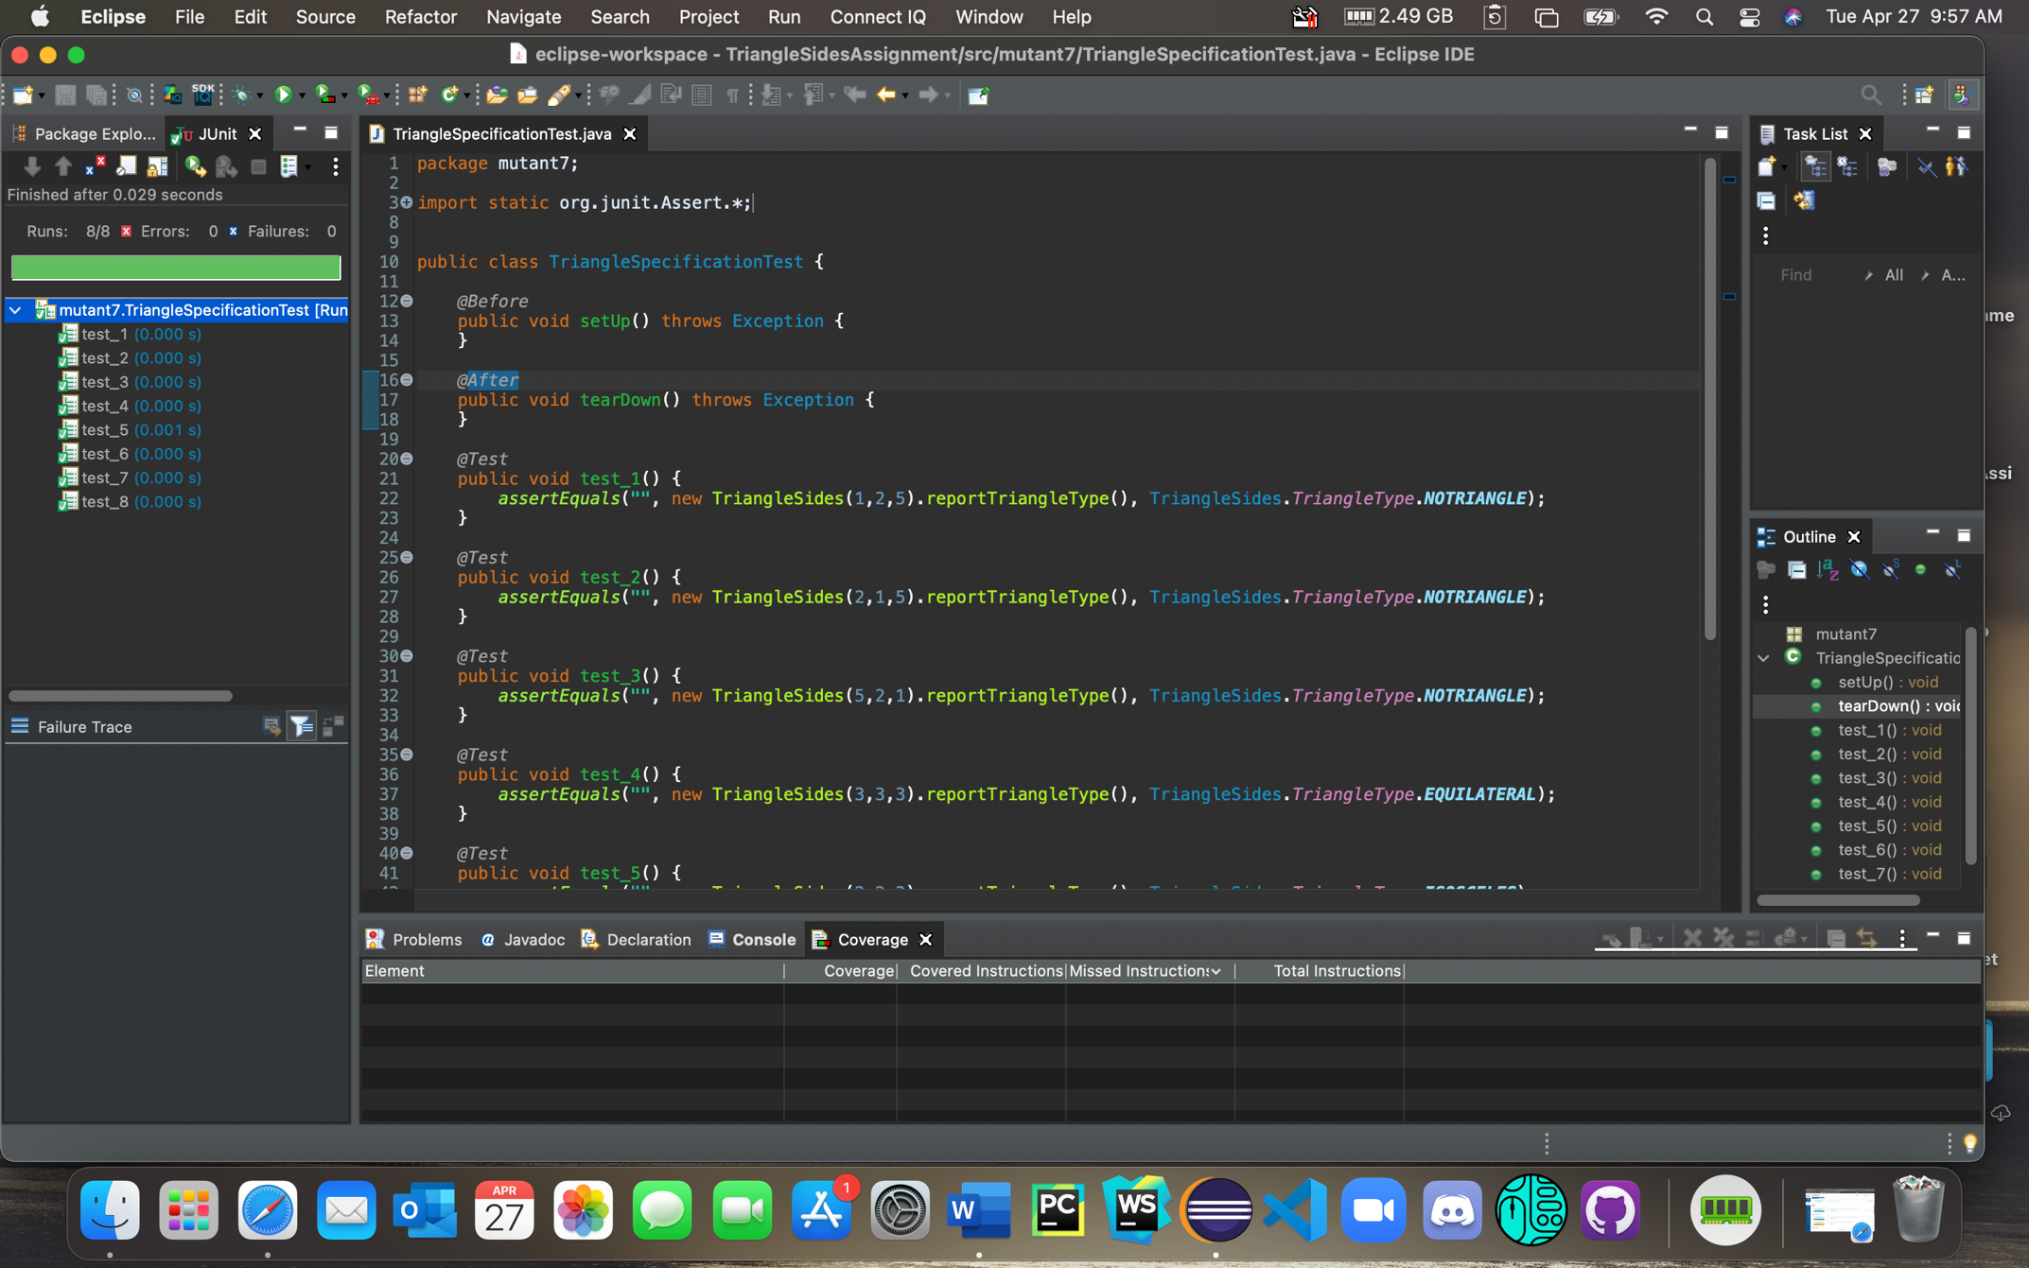

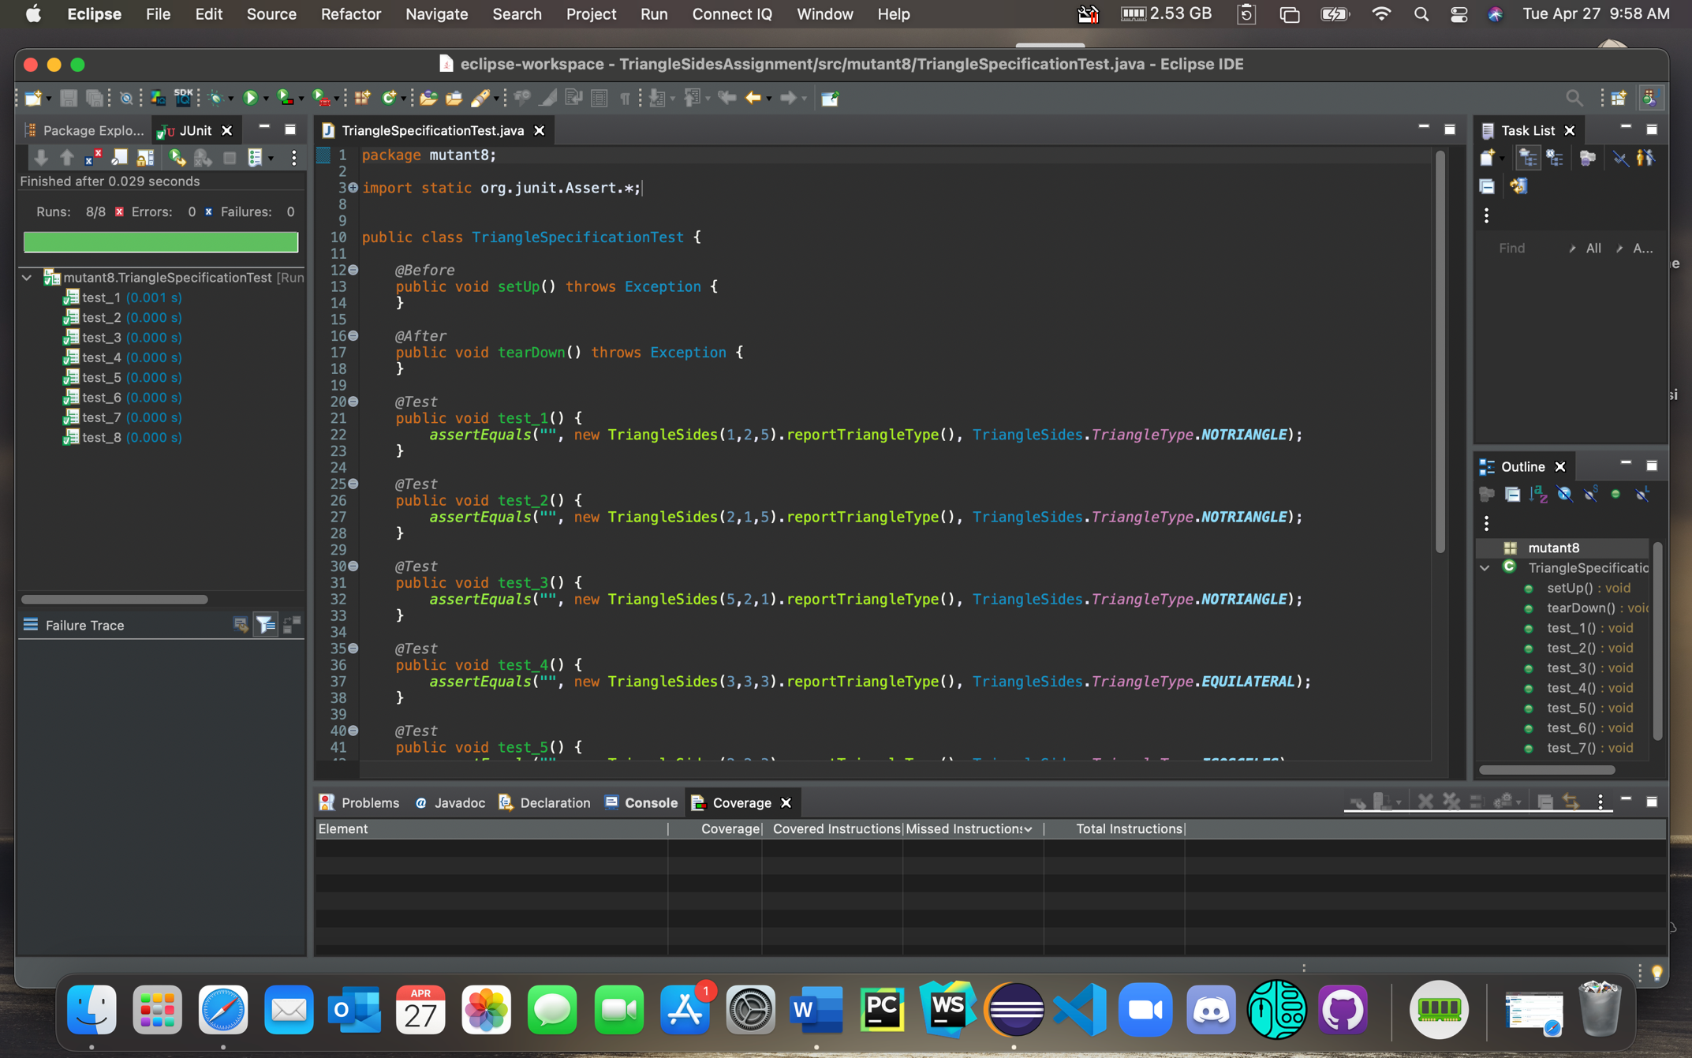

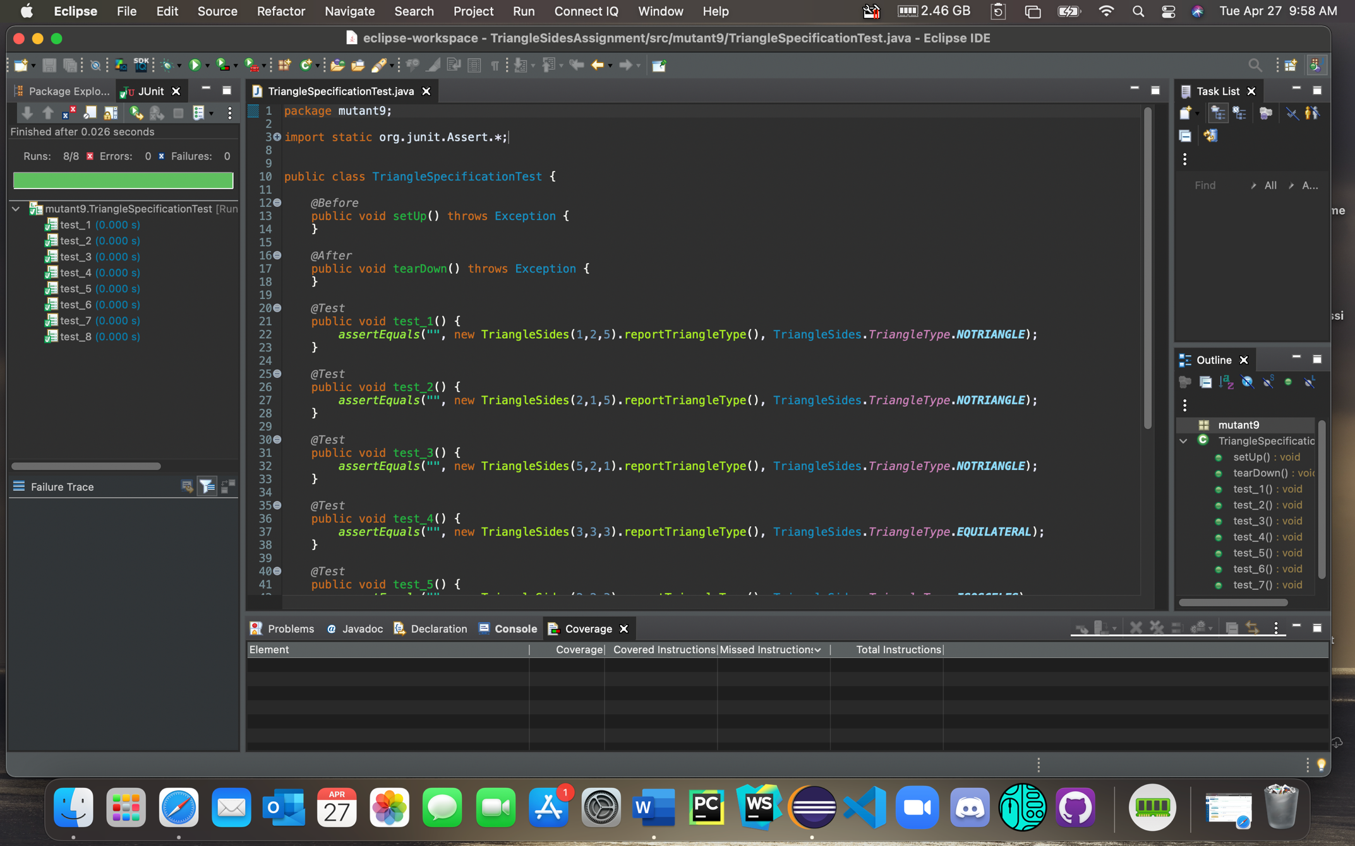

**2. Combinatorial Testing**

Download the ACTS tool from Canvas and uses its default IPOG method to generate combinatorial tests for the following problems.

* 1. **ISBN10 (20 points)**

In a valid ISBN-10 number, each of the first 9 characters is a digit (i.e., 0-9) and the 10th character is a digit or X (i.e., 0-10). Assuming the weighted sum of the 10 digits is not considered, use ACTS to determine the numbers of 2-way and 3-way combinations. Submit the following: (a) the numbers of 2-way and 3-way combinations, (b) the screenshots of the results reported by ACTS.

First 9 variables in range [0-9] and 10th variable in range [0-10]

ACTS strengths of 2 and 3 used to for desired 2-way and 3-way combinations

2-way combinations - 159

3-way combinations - 2469

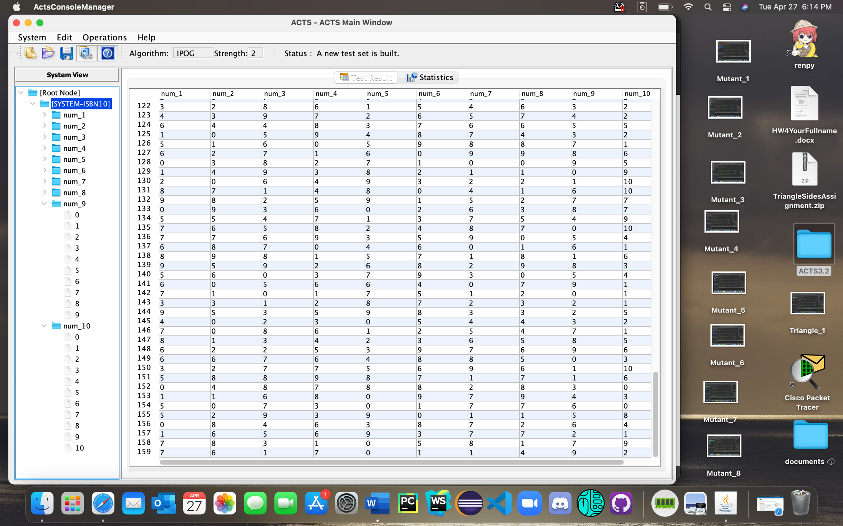

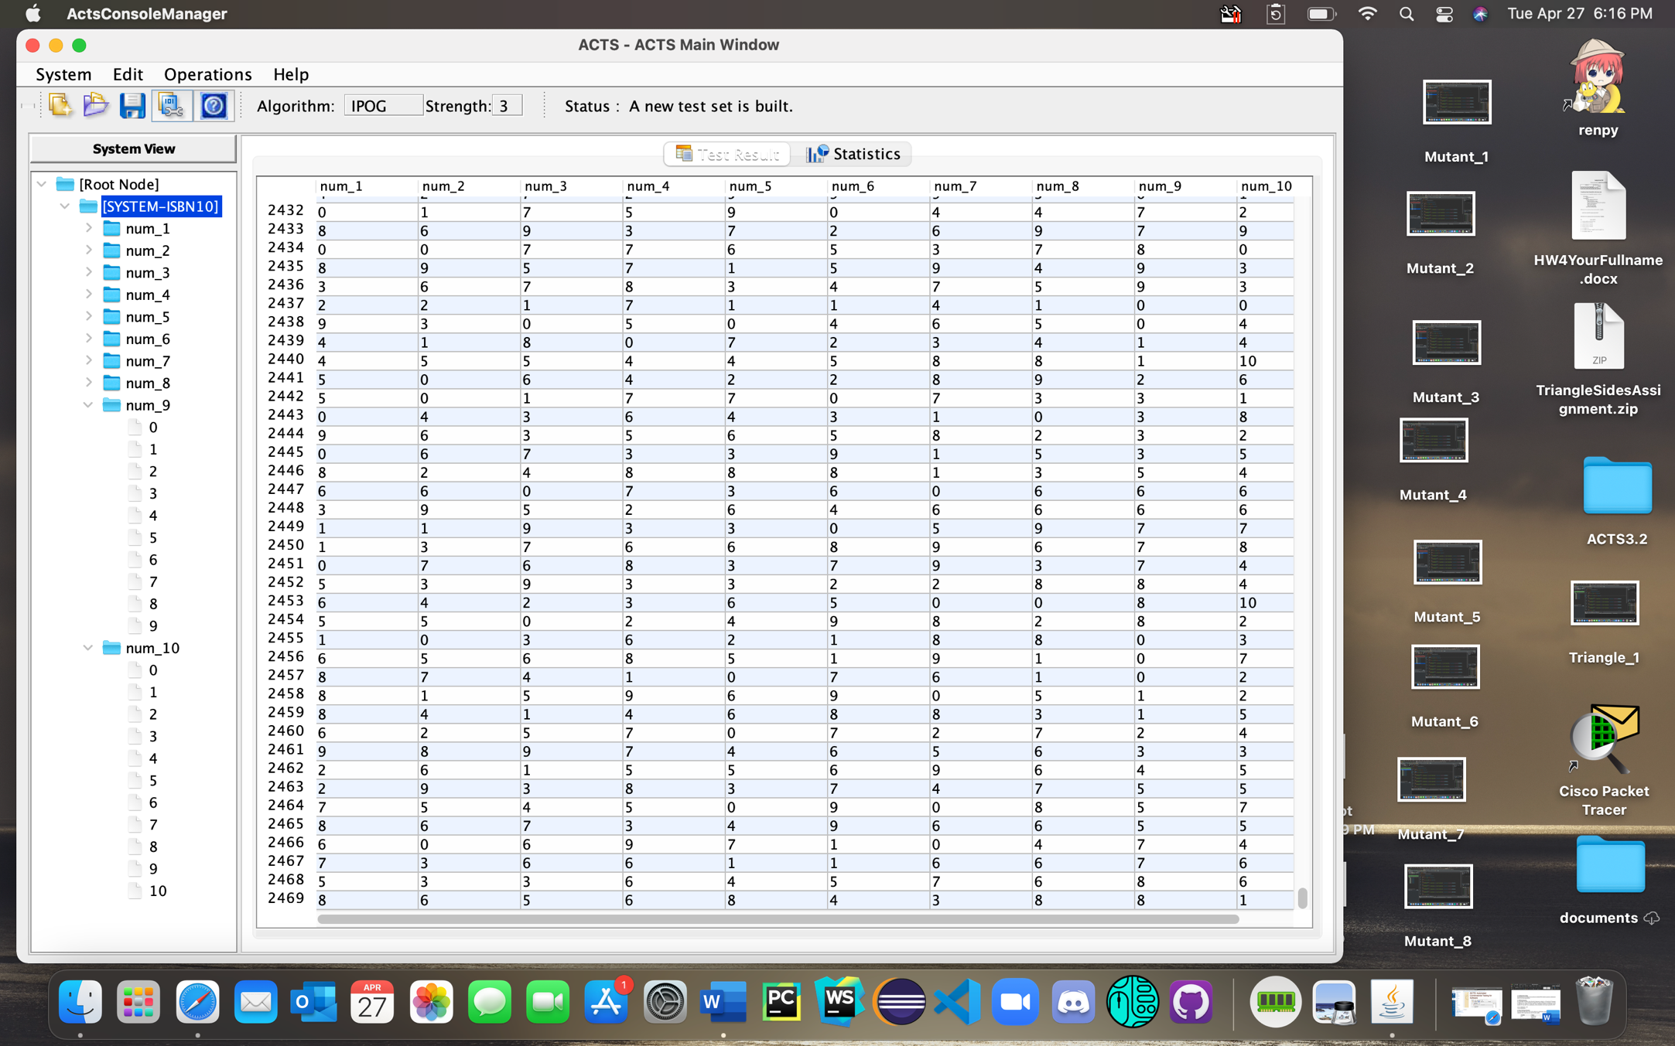

* 1. **Pizza Ordering (20 points)**

The following table shows some of the options for customizing a pizza at papajohns.com. For simplicity, here we pick only one value for each variable.

|  |  |
| --- | --- |
| **Variable** | **Values** |
| Cut | Normal Cut  Square Cut  Clean Cut  No Cut |
| Sauce | BBQ  Ranch  Original  Buffalo  Alfredo Sauce |
| How much sauce? | Normal Sauce  Light Sauce  Extra Sauce  No Sauce |
| Bake | Normal Bake  Well Done |
| How much cheese? | Normal Cheese  Light Cheese  No Cheese |
| Meats | Salami  Bacon  Anchovies  Sausage  Grilled Chicken  Meatball  Philly Steak  Canadian Bacon  Pepperoni  Spicy Italian Sausage  Beef |
| Veggies | Fresh Spinach  Onions  Pineapple  Roma Tomatoes  Mushrooms  Jalapeño Peppers  Banana Peppers  Green Peppers  Black Olives |

Use ACTS to determine the number of 2-way and 3-way combinations. Submit the following: (a) the numbers of 2-way and 3-way combinations, (b) the screenshots of the results reported by ACTS.

Variable cut has range [1-4], variable sauce has range [1-5], variable sauce_quantity has range [1-4], variable bake has range [1-2], variable cheese_quantity has range [1-3], variable meats has range [1-11], variable veggies has range [1-9]

ACTS strengths of 2 and 3 used to for desired 2-way and 3-way combinations

2-way combinations - 99

3-way combinations - 506

